LAB Logbook

Lab 1
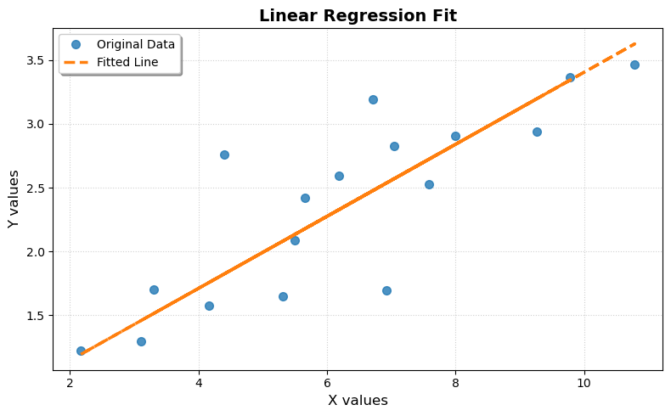
Lab 2
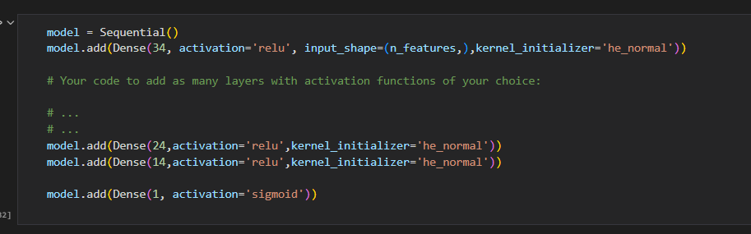
Test Acc: 0.9722222089767456
SSID | 2465589 | Final Output | 0.824842264
Lab 3
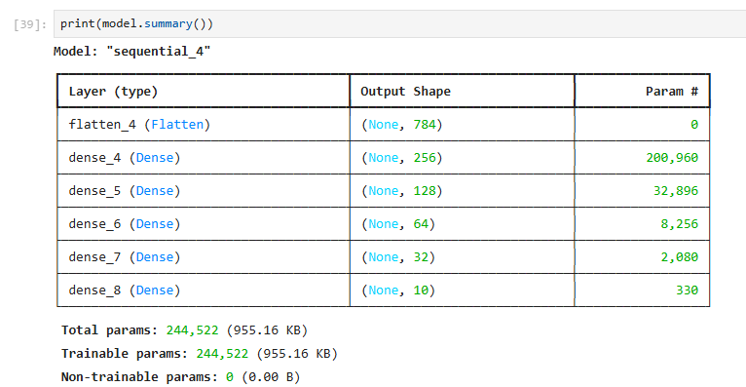
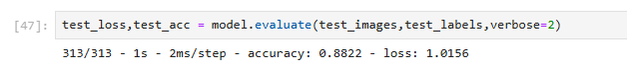
Lab 4
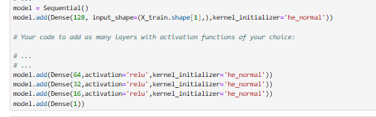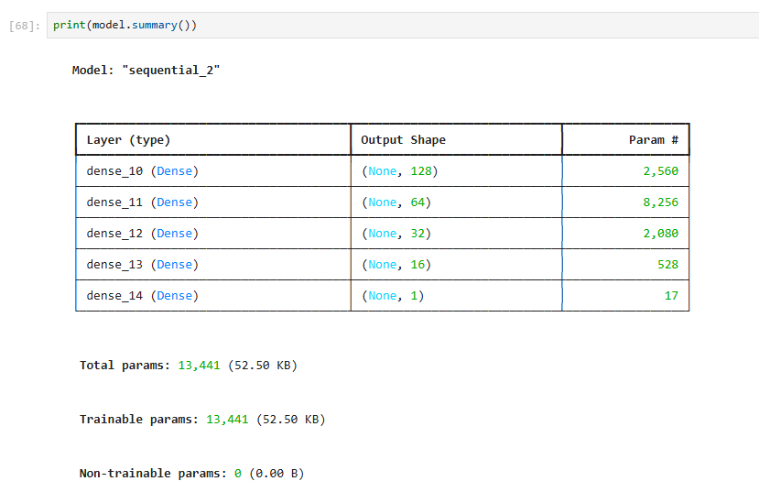

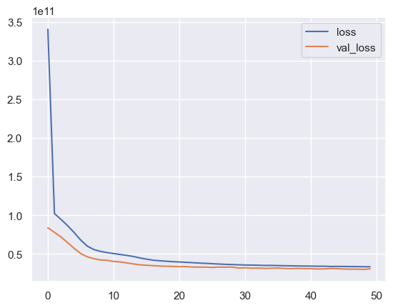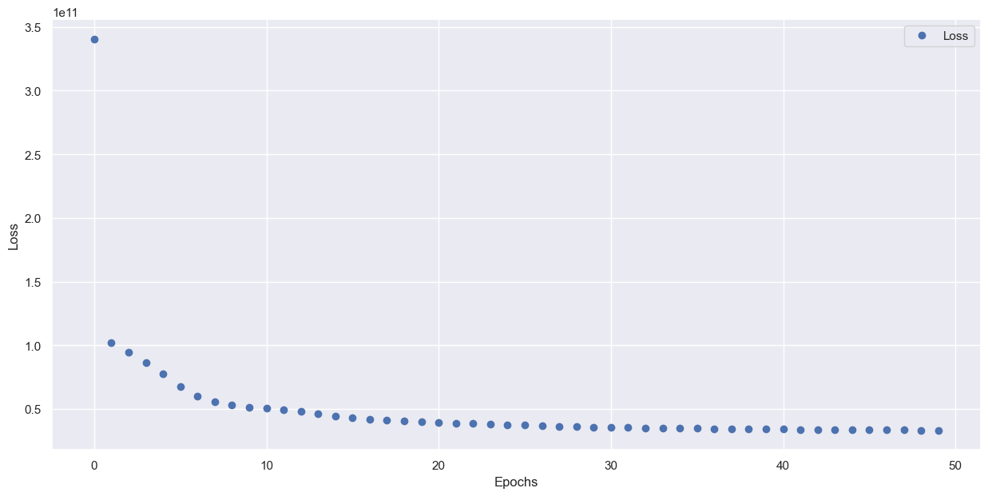
Lab 5

Lab 6

Lab 7

Lab 8

Lab 9

Lab 10

Lab 11

Lab 12

